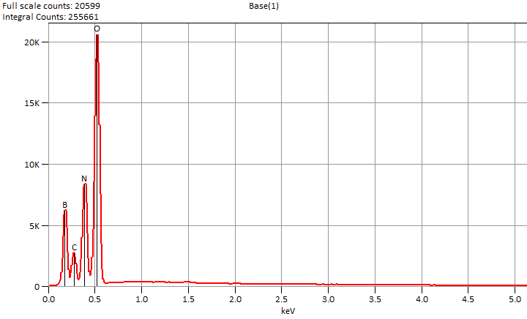

Live Time: 100.0 sec.

Tue Dec 10 11:35:10 2024

Filter Fit Chi Squared:73.027

Errors: +/- 1 Sigma

Correction Method: Proza (Phi-Rho-Z)

Acc.Voltage: 5.0 kV Take Off Angle: 34.1 deg.

Detector: UltraDry

WDS Results Unavailable for: Base(1)

|  |
| --- |
|  |

Quantitative Results for: Base(1)

|  |  |  |  |  |  |  |
| --- | --- | --- | --- | --- | --- | --- |
| ***Element***  ***Line*** | ***Int.***  ***Cps/nA*** | ***Int.***  ***Error*** | ***Weight %*** | ***Weight %***  ***Error*** | ***Atom %*** | ***Atom %***  ***Error*** |
| ***B K*** | 41.11 | ± 0.62 | 11.1 | ± 0.2 | 15.0 | ± 0.2 |
| ***C K*** | 17.06 | ± 1.05 | 2.9 | ± 0.2 | 3.6 | ± 0.2 |
| ***N K*** | 52.67 | ± 0.81 | 20.8 | ± 0.3 | 21.8 | ± 0.3 |
| ***O K*** | 166.80 | ± 1.02 | 65.2 | ± 0.4 | 59.7 | ± 0.4 |
| ***Total*** |  |  | 100.0 |  | 100.0 |  |

ROI Results for: Base(1)

|  |  |  |
| --- | --- | --- |
| ***Operation*** | ***Gross Counts*** | ***Net Counts*** |